1 Unit 4 Progress Check – Multiple Choice Questions
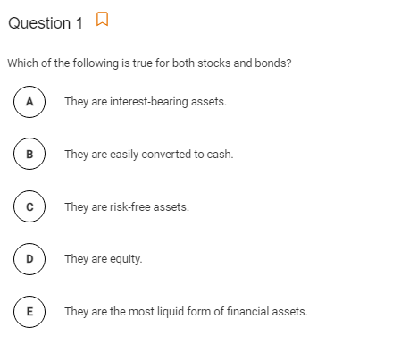

2
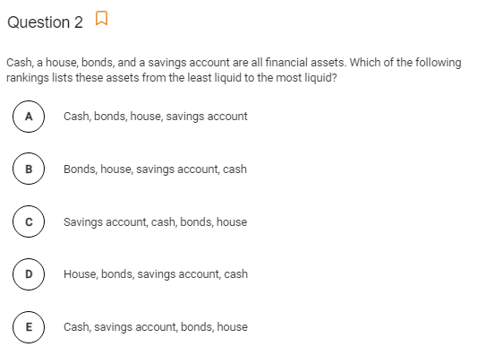

3
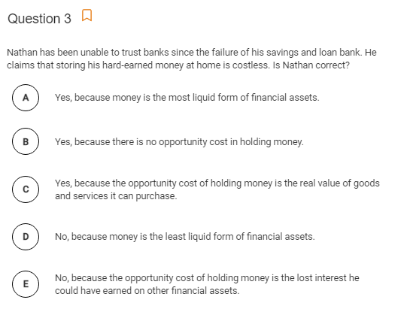

4
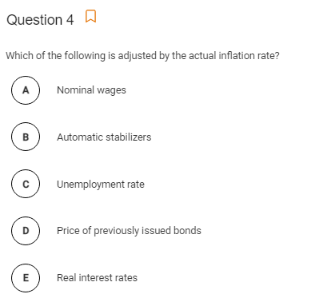

5
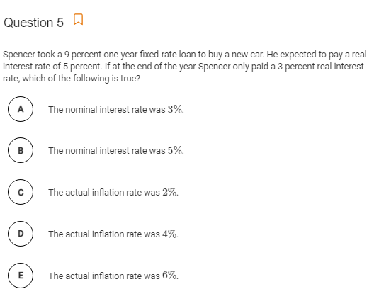

6
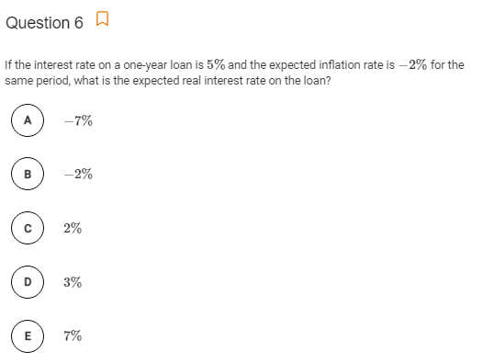

7
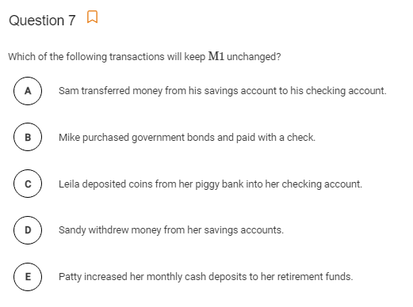

8
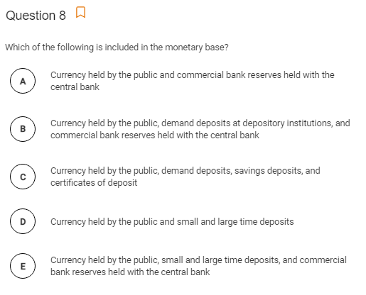

9
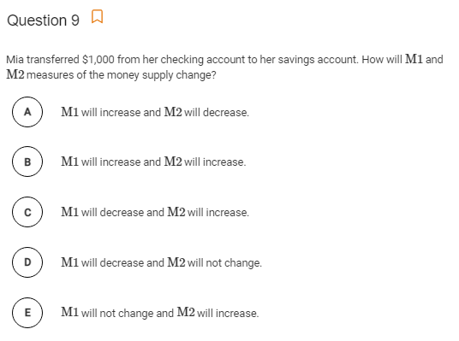

10
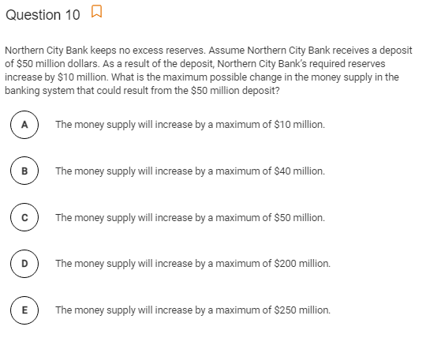

11
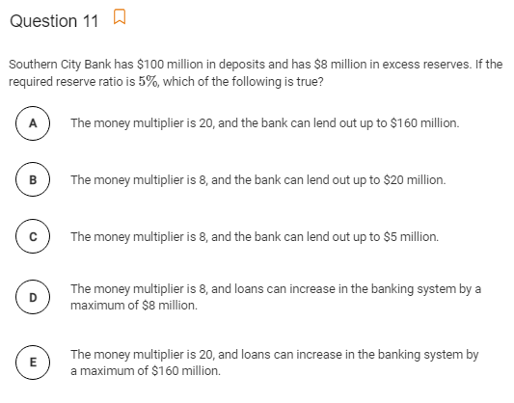

12
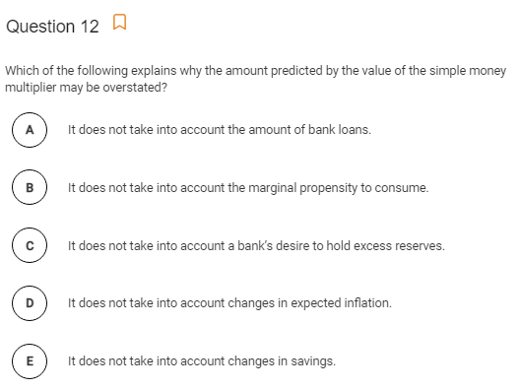

13
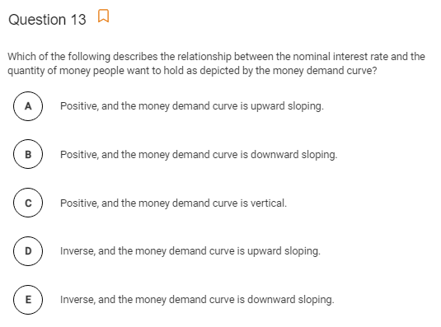

15
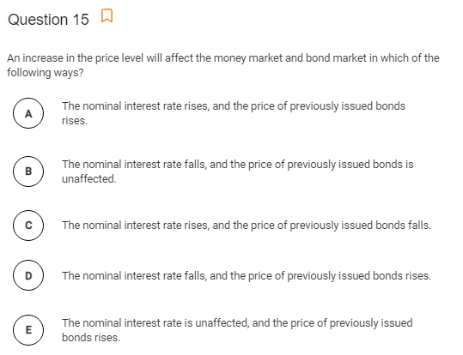

14
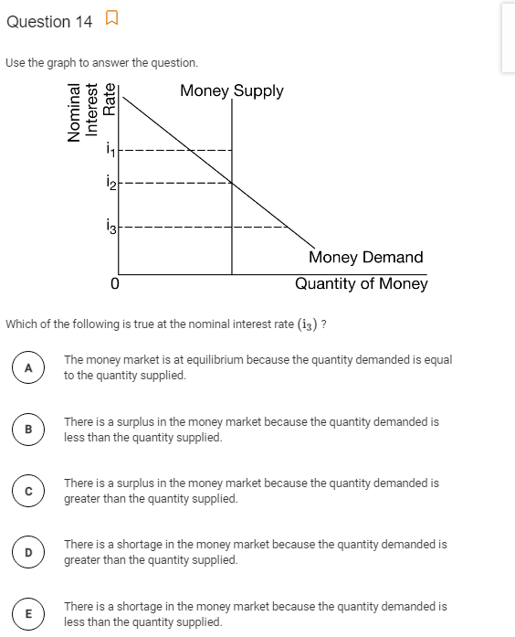

16
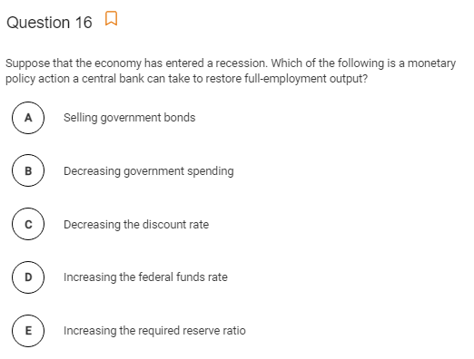

18
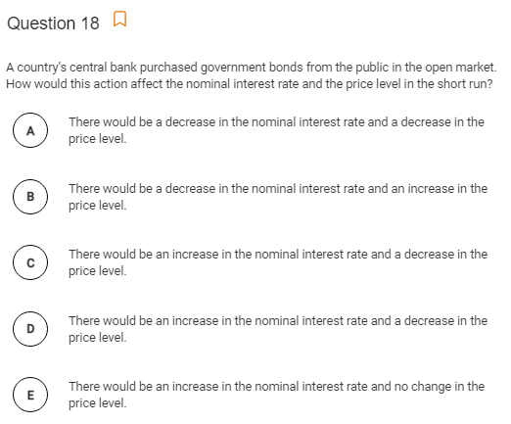

17
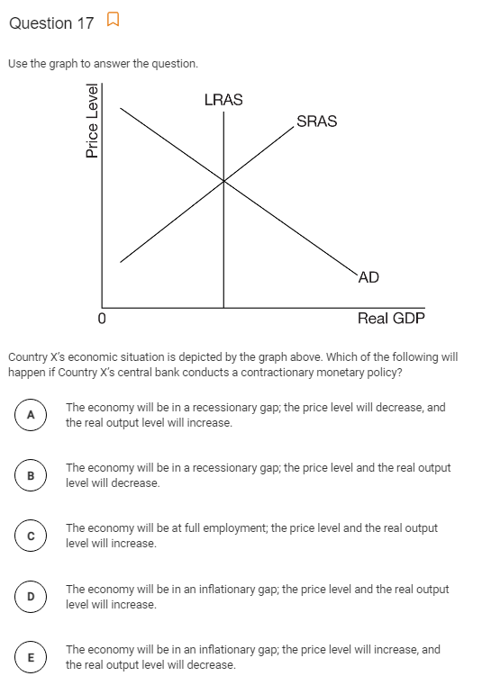

19
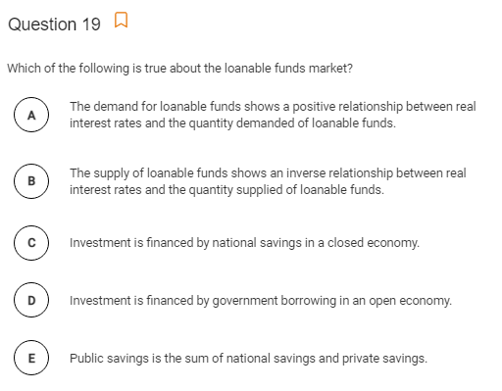

21
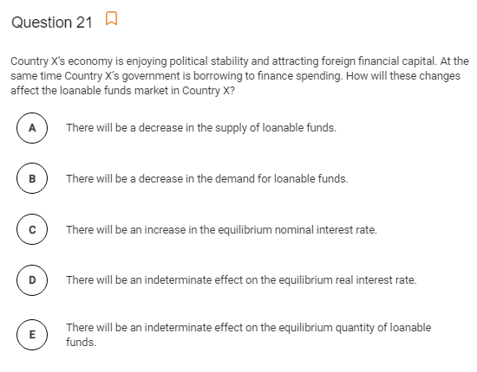

20
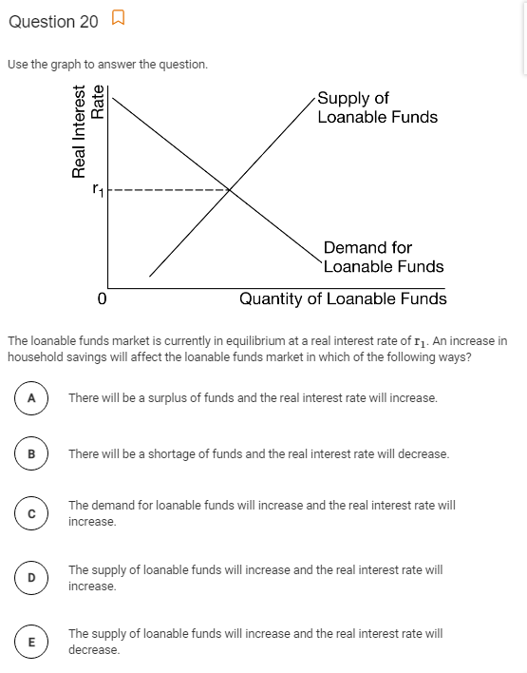

21
21. Country X’s economy is enjoying political stability and attracting foreign financial capital. At the same time Country X’s government is borrowing to finance spending. How will these changes affect the loanable funds market in Country X?
A There will be a decrease in the supply of loanable funds.
B There will be a decrease in the demand for loanable funds.
C There will be an increase in the equilibrium nominal interest rate.
D There will be an indeterminate effect on the equilibrium real interest rate.
E There will be an indeterminate effect on the equilibrium quantity of loanable funds

Answers
1 | B | 11 | E | 21 | D
2 | D | 12 | C
3 | E | 13 | E
4 | E | 14 | D
5 | E | 15 | C
6 | E | 16 | C
7 | C | 17 | B
8 | A | 18 | B
9 | D | 19 | C
10 | D | 20 | E

